Year 9

Look at the examples of artwork below and plan your own tribute to a hero of yours.

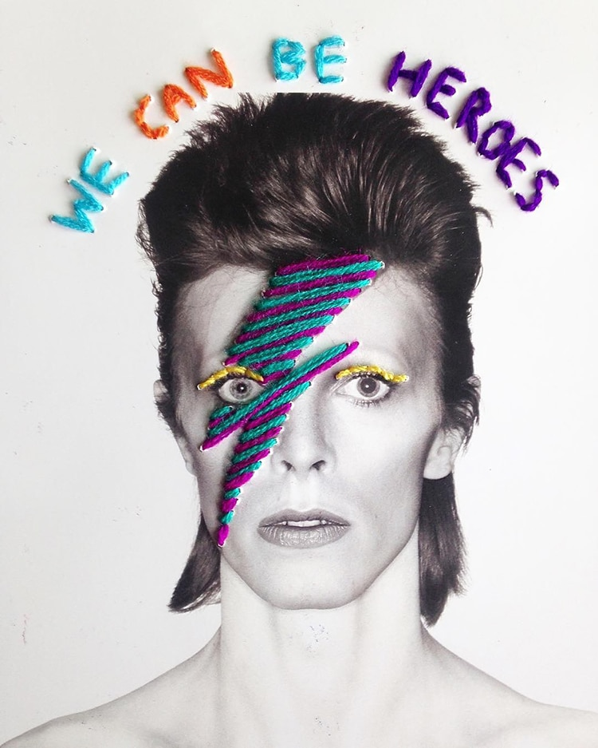

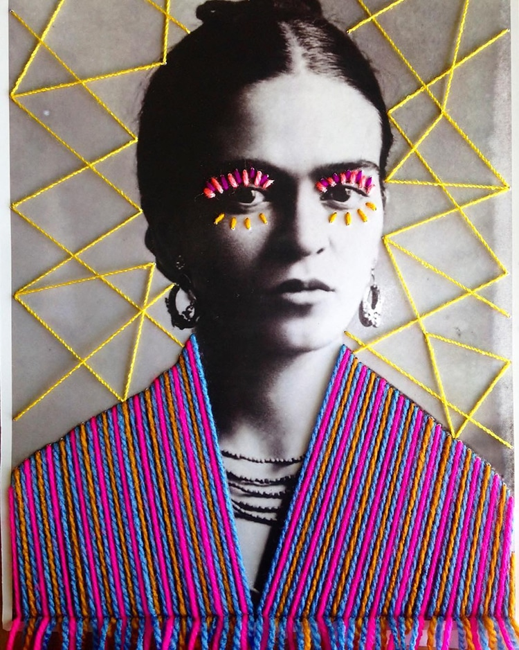

Mexico-based textile artist Victoria Villasana applies colourful embroidery designs to vintage black and white photographs of cultural icons. Inspired by world culture and the human spirit, Villasana explores “how people relate to each other in a fragmented, post-digital world.”

From feminist heroines such as Frida Kahlo, to world-adored musicians such as David Bowie, Villasana’s chosen imagery depicts people who she calls “true visionaries,” meaning “people who realise their inner power to change things.” Throughout her works, rainbow coloured stitches—in geometric and polka dot patterns—are used to highlight the subject’s clothing, jewellery, and eyes. Villasana’s aim is to “keep the message of these visionaries in our minds and hearts.”

Have a look at the article.

https://mymodernmet.com/colorful-embroidery-vintage-photos-victoria-villasana/?fbclid=IwAR2j_8TlD1CSGCKw8uPwSYj8hHKvfX-7Y4KjG3YdZh9LVFT75ZBzDRbuCxw
Who would you celebrate in this way?
What colours would you use?
How would you apply the colours?
What designs and patterns would you add?
Would you print out the face or draw it?

Suggestions and Help:

You might have a poster, postcard or other real image you are happy to work on top of.
You might include words, a slogan or a quotation.
You could cut out or print out just the persons face and draw or collage the rest of the picture.
You could use collage using coloured string, magazine pictures, or print-outs of images.
You could sew, knit or use another craft you already do.
Sharpie pens draw on top of most things.
Your artwork could be any shape or size. Work on a plate, or a T-shirt for example.
Mixed media in one piece of work can give you a lively and interesting result.

