Core Mathematics
OCR MEI B
Independent Scholarship Award
Name: |  | Bronze/Silver/Gold

Bronze
- Answer the following questions on percentages:
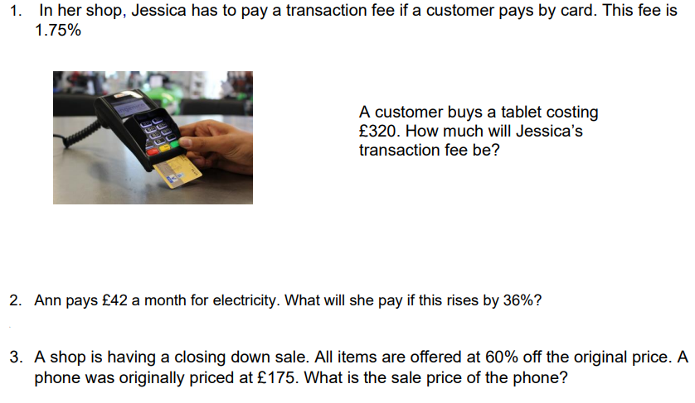

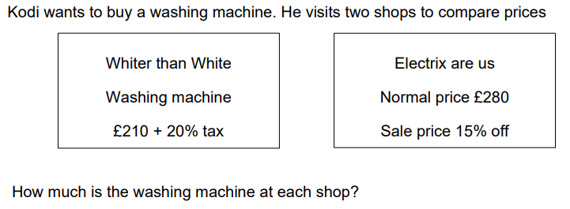

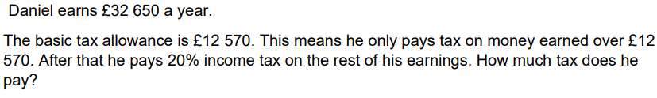

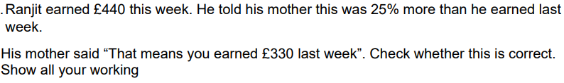
7.

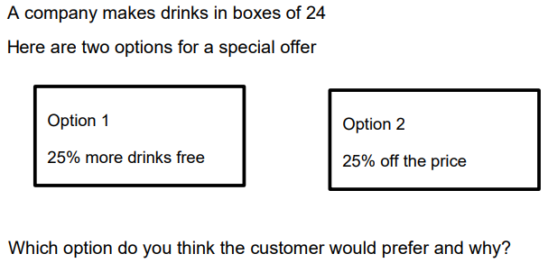
8.

Silver
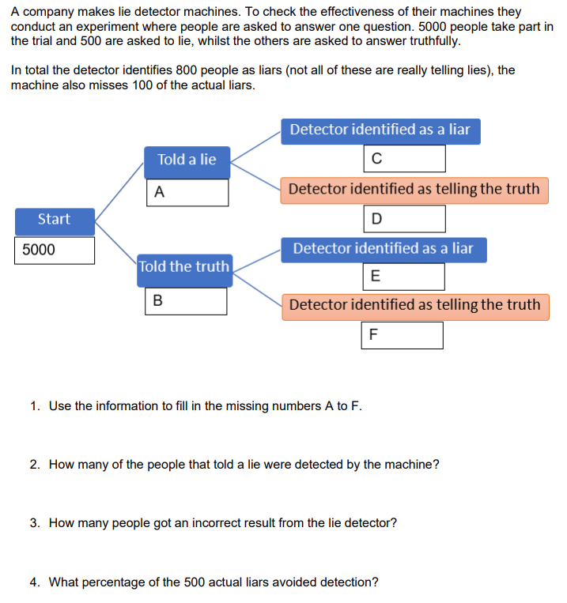
- Complete Bronze and the following:

Gold
- Complete Bronze and Silver and the following:
Create a detailed poster/fact file on the importance of statistics or uses of statistics in daily life. Here are some resources to get you started:
- https://coursementor.com/blog/uses-of-statistics-in-daily-life/
- https://www.statology.org/why-is-statistics-important/
- https://statanalytica.com/blog/uses-of-statistics/
COURSE DETAILS:
- We study OCR Core Maths B. This link takes you to the specification https://www.ocr.org.uk/Images/173574-specification-accredited-core-maths-b-mei-h869.pdf

GET ORGANISED
- Come prepared at the beginning of term, this will help you to keep your notes and any handouts organised. You will need:
- a ring binder folder, plastic wallets, file dividers
- pencil case with pen, pencil, highlighters, ruler protractor and compass
- lined / squared paper
- a scientific calculator. Rainham mark sell the advanced graphical calculator CG50 and the classwiz 991EX.
GET INSPIRED:
To Watch:
- Why Core maths?
https://www.youtube.com/watch?v=Y51Of3G624I
- Martin Lewis Student loans decoded https://www.youtube.com/watch?v=mO_rAsMuAlM

- To Read:
http://quibans.blogspot.com/

QUESTIONS, QUERIES AND COMMENTS:
- Use this section to make a note of anything you would like to ask your teacher about when the course starts in September.

