A LEVEL ENGLISH LITERATAURE
INDEPENDENT SCHOLARSHIP AWARD
Firstly, thank you for choosing A level English Literature as one of your options next year. We love teaching this course and hope you will enjoy being in our classes next year. We often use a phrase to connect English Literature at GCSE and A level: it’s similar but different.
Similar because you study novels, poetry and plays, and then write about them.
Different because the texts are a touch more challenging (the A in A level stands for ‘advanced’) and our expectations of you are even higher.
At GCSE you read your set texts, get to know them really well and practise writing about them. In addition, at A level, we expect you to:
- Take an even more autonomous approach to your study of the set texts, organising your folders, taking notes and reworking those notes.
- Read literature beyond your set texts, to enrich your understanding of those set texts and for your own personal pleasure.
- Read scholarship. We want you to develop your interpretations of the texts you have studied by reading what experts have written about them.
You will find out more about the structure of the A level course when you start in September, but the following three levels of task have been designed to prepare you for the transition between GCSE and A level. You must complete the first one; we hope you will be inspired to complete the other two as well. After all, it’s a long time between now and September!

BRONZE TASKS – COMPULSORY
- As preparation for the ‘Elements of Tragedy’ module we would like you to research the conventions of Shakespearean tragedy. Make sure you use reputable sources when researching. We recommend the British Library article ‘An Introduction to Shakespearean Tragedy’, ‘Definition and Characteristics of Shakespearean Tragedy’ on Owlcation and Lesson 7 from John Lennard’s ‘Tragedy: A Complete History’ on Massolit (many of you will have already signed up to Massolit, but if you haven’t you should / must create a free account, using your school email address). Please go beyond these suggestions and write up your notes ready to submit to your teacher in the first week back – no plagiarism, no cutting and pasting, your words.
- As preparation for the ‘Elements of Political and Social Protest Writing’ module, please follow the instruction to complete the research and analysis tasks based on William Blake’s collection ‘Songs of Innocence and of Experience’ (you should recognise one of his poems at least!)

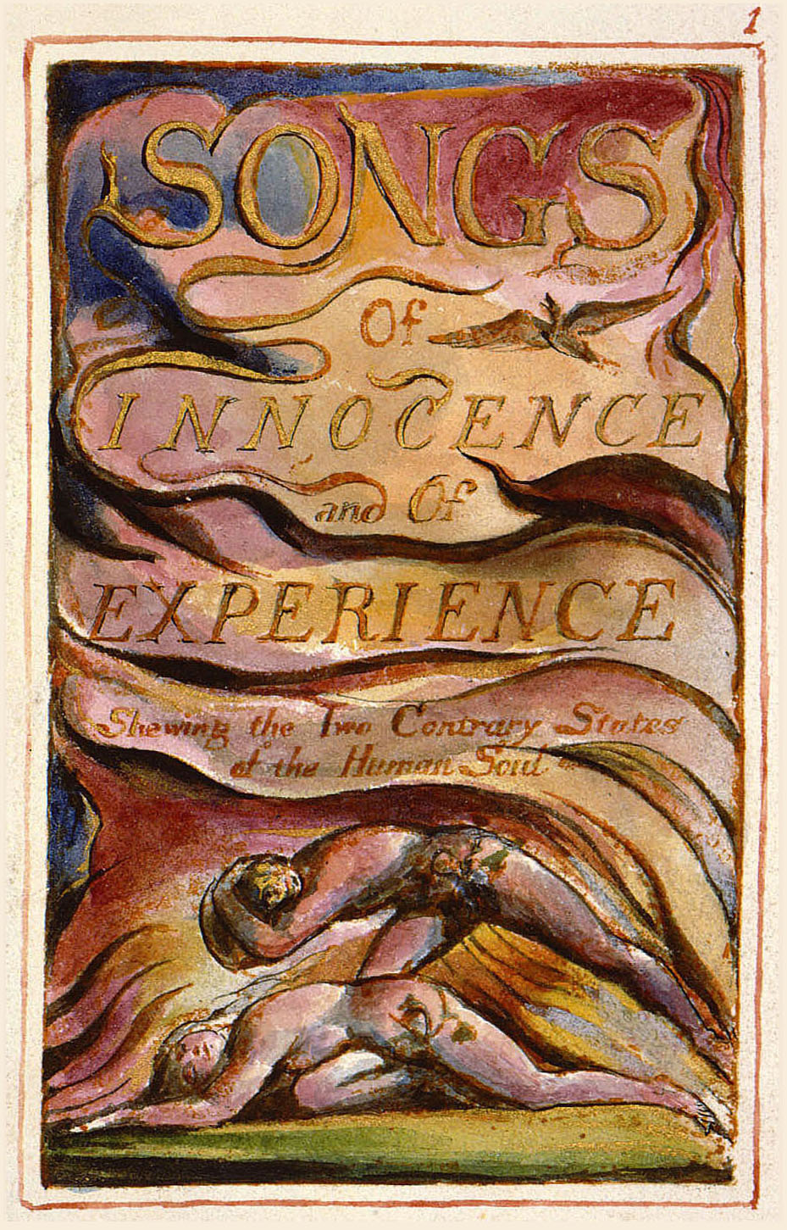
The ‘Songs of Innocence’ were published in 1789. Five years later Blake added the ‘Songs of Experience’ and since their publication in 1794 the two parts have been published as one collection. The latter part of the 18th century was a very interesting period of history and we would like you to begin by completing some simple research on the following topics:
- The Industrial Revolution in Great Britain, specifically with regard to wealth generation, the expansion of British cities and the condition of the poor.

- The French and American Revolutions, specifically focusing on the regimes in control of France and the American states prior to the revolutions, the motivations / objectives of the revolutionaries and how fear of revolutionary ideas spreading to England prompted a series of measures from the British government.

- The pastoral tradition in literature, specifically focusing on use of the term prior to 1610 to describe literature that presented lives of shepherds and the more modern use of the term to describe literature which presents the countryside. You might even wish to investigate Jonathan Bate’s ideas about ‘The Great Pastoral Con Trick’

WRITE UP YOUR FINDINGS IN BULLET POINT NOTES – NO MORE THAN A PAGE PER TOPIC
This poem is from the ‘Experience’ part of the collection. It’s one you will likely be familiar with because you will probably have studied it at GCSE. Your research on the effects of The Industrial Revolution, the French and American Revolutions and the philosophy of Rousseau and Voltaire will be useful here.

Read the poem, look at the annotations and the question. Look at the model answer.
Repeated adjective suggests how the city is taken over by commerce and trade
London
BY WILLIAM BLAKE
I wander thro' each charter'd street,
Near where the charter'd Thames does flow.
And mark in every face I meet
Marks of weakness, marks of woe.
Repetition of “every” conveys the ubiquity of suffering amongst citizens of London

In every cry of every Man,
In every Infants cry of fear,
In every voice: in every ban,
Metaphor to symbolise ideological control-the masses have been metaphorically shackled, manipulated to believe their plight is hopeless.
The mind-forg'd manacles I hear

How the Chimney-sweepers cry
Suffering of the oppressed-each character is an innocent victim of exploitation by those in positions of power/authority
Every blackning Church appalls,
And the hapless Soldiers sigh
Runs in blood down Palace walls

But most thro' midnight streets I hear
How the youthful Harlot’s curse
Blasts the new-born Infants tear
And blights with plagues the Marriage hearse

In ‘London’ how does Blake convey the horrific plight of the poor to his readers and imply that Britain would benefit from a revolution similar to that in France?

The poem takes as its form a random “wander” through the streets of the capital, Blake’s speaking noticing and recording (“mark in every face I meet”) the plight of the city’s poor. It is governed by a balance between visual and auditory imagery, the speaker seeing the “marks of weakness, marks of woe” in the city’s population (presumably their ragged appearance, signs of malnourishment and disease and so on) and hearing their woeful cries of desperation. Blake links this directly to the fact that London is a centre of commerce, a place where trade dominates every “chartered street” and even the mighty Thames river, which would have been full of merchant ships bringing in imported raw materials from ‘the new world’, being packed with goods for export and, shamefully, journeying to the west coast of Africa to coerce slaves into making the journey across the infamous middle passage.
Interestingly, Blake shows a contrast between the marginalised poor and the powerful establishments that govern the country. So, the monarchy (represented by the “palace”) send desperate men to risk their lives fighting in wars and the religious establishment (represented by the church) ignore the plight of young chimney sweepers who worked in terrible conditions and had their life expectancy cut short by their dangerous trade. A further example of exploitation is presented in the final stanza. A young girl, no more than a child herself, is forced to sell herself for sex with strangers, risking disease and death so that she can try and cobble together enough money to provide for herself and her new born child. It seems that this is a society where everything is for sale, including human beings. So why don’t the people who are suffering follow the lead of the French and the Americans who fought back against their oppressors in favour of freer, more socially just societies?
The central metaphor of the poem is the “mind-forg’d manacles.” The poor and vulnerable are metaphorically shackled, trapped in their circumstances. The establishment control and shape their thinking, like ideological blacksmiths moulding molten metal into a shape which suits them – it is in the interest of the monarchy, the church and all those who represent the powerful elite in society to keep the poor in their servile position, exploitable and unlikely to offer any resistance. However, there’s a double meaning to forged, it also carries connotations of something counterfeit. The constraints on the poor are illusory and if / when the disenfranchised underclass realise their condition they will able to rise up and overthrow the tyrannical forces in society which keep them in their subservient state.

TASK: read and annotate all four poems below. Then choose one question to answer, using the response to ‘London’ as a guide to the length and style of your response.

- This poem is from the ‘Innocence’ part of the collection. Your research on pastoral literature and the French and American Revolutions will be useful here.

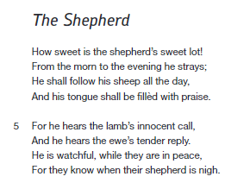

In ‘The Shepherd’ how does Blake use his pastoral scene as an allegory for an ideal society?
- This poem is from the ‘Innocence’ part of the collection. Your research on the philosophical ideas of the Enlightenment and the French and American Revolutions will be useful here.

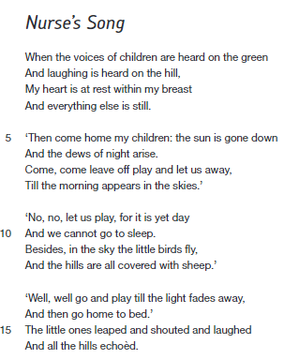

In ‘Nurse’s Song’ how does Blake convey ideas about the importance of freedom in society and allegorise ideas about resisting those in positions of power?
- This poem is from the ‘Innocence’ part of the collection. Your research on the effects of the Industrial Revolution (you might need to top this up by further research into the role of chimney sweepers in society) will be useful here.

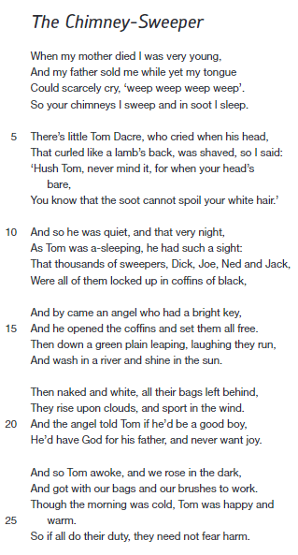

In ‘The Chimney Sweeper’ how does Blake convey his disgust at the appalling treatment of chimney sweepers during the latter part of the 18th century?
- This poem is from the ‘Experience’ part of the collection. Your research on the effects of the Industrial Revolution will be useful here.

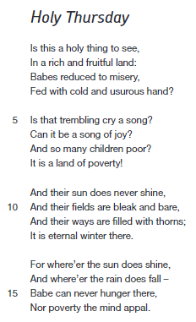

In ‘Holy Thursday’ how does Blake present his anger at the injustices of late 18th century society, which he saw as being polarised between extreme wealth and extreme poverty?
SILVER TASK – OPTION ONE
What is ‘political and social protest writing’? AQA (the exam board who have designed our course) describe it as a literary genre, but it’s not a genre like crime or horror or romance; it’s much broader than that.
You are no stranger to literary works which are political – ‘Lord of the Flies’, ‘Macbeth’ and many of the ‘Power and Conflict’ poems explore political themes. That’s not in the sense of political parties (such as Conservative, Labour, LibDem, Green, Democrat, Republican), but in the sense that Golding and Shakespeare and Agard and Dharker and others are interested in:

- Inequality
- Abuse of power
- Exploitation
- Giving a voice to the voiceless
- Surveillance
- Human rights

- Oppression
- Coercion and control
- Class consciousness and struggle
- Hypocrisy of those in power
- Resistance of the human spirit
- The individual versus the state

This exciting genre of literature pulls no punches; it will provoke you to think deeply about the world you live in and encourage you to look at society in a different way. For the silver task, we would like you to select a novel, read it and then write a short report on the political and social protest themes that interested you in the novel. There’s an example below, my attempt to write about ‘Lord of the Flies’ as a political / social protest text. We would recommend the senior and contemporary fiction section of the school library, which holds some excellent novels, and all your favourite teachers from the English department have given you their recommendations below:

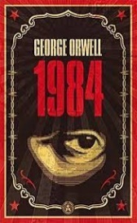 | ‘1984' by George Orwell. He describes it as a classic of dystopian literature, depicting a totalitarian future which has stripped individuals of the freedom to think. Published at the start of the Cold War, against the backdrop of the ideological struggle between capitalism and communism, interpretations of the text range from anti-communist to anti-fascist. Spawning the notions of Big Brother, Room 101 and the Thought Police, Orwell's warning to humanity remains terrifyingly relevant in today's society.
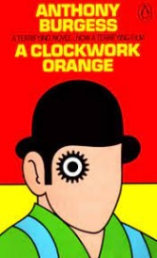 | ‘A Clockwork Orange’ by Anthony Burgess. She describes it as a challenging, terrifying, and, at times frustrating fable about humankind's capacity for cruelty and the importance of freedom.
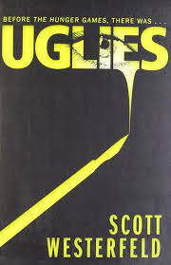 | ‘Uglies’ by Scott Westerfeld. He describes it as a modern, science fiction novel (2005), set in a future dystopian world in which everyone is considered an 'ugly', but then turned 'pretty' by extreme cosmetic surgery when they reach the age of 16. It’s a powerful story that explores issues of conformity, state control and rebellion.
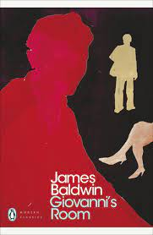 | ‘Giovanni's Room’ by James Baldwin. He describes it as an American novel from the mid-20th century, notable for its sympathetic exploration of gay and bisexual life at a time when it was criminalised and persecuted. Baldwin's novel is a brilliant exploration of individual guilt, fuelled by an underlying anger at the institutions and social attitudes that force people to feel it in the first place.
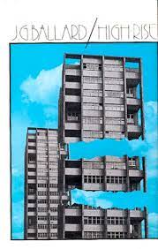 | ‘High Rise’ by JG Ballard. He describes it as a fascinating depiction of a dystopian society. When an architect’s vision of a Utopian living space goes wrong Ballard’s satire kicks in as he explores humanity's innate need to form hierarchies and tribes. Think 'Lord of the Flies' in an East London tower block – spoiler alert: it doesn’t end  well for the Alsatian!
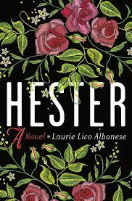 | ‘Hester' by Margaret Oliphant, a brilliant late Victorian novel by a great female Victorian writer. Hester's narrative is one of ordinary Victorian life which has been described by critics as "remorselessly true". Oliphant depicts the challenge of being a woman in Victorian society, the flaws of patriarchy and the dangers of trusting men to do what is right.
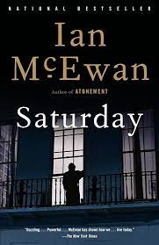 | ‘Saturday' by Ian McEwan. Set against the backdrop of the US invasion of Iraq in 2003, the novel deals with personal feelings on war and collective responses to the threat of war. The novel tracks through the London protest against the invasion which was, at the time, the largest protest in British history. An interesting aspect is the way that family members discuss political issues and how they often don't agree and find themselves ideologically opposed.

Reading ‘Lord of the Flies’ as a political and social protest text
For most readers ‘Lord of the Flies’ is simply a novel about what happens to children when you take away adults from the equation. It has become a byword for unruly / feral young people pushing at authority. That difficult class you have to teach on a Friday afternoon? A stressed teacher might say of the lesson, it all went a bit ‘Lord of the Flies’.
However, I read the novel differently. For me the story of children abandoned on an unspecified tropical island somewhere in the Pacific Ocean is an allegory which allows Golding to explore ideas about society and concerns about dangerous political ideologies.
For example, in the first few chapters the boys replicate the recognisable structures of the British political system – the platform is like the Houses of Parliament, Ralph is like the prime minister and the conch symbolises everyone’s right to be heard in a democratic society. If we take this a stage further and consider that Golding was inspired to write the novel by his experiences in the second world war, then perhaps the conch could be seen as representing the fragility of democracy. Golding’s novel could be seen as a warning against complacency. Unless we stand firmly against tyranny we might find ourselves losing the values of democratic societies – freedom, the rule of law (Jack says ‘bollocks to the rules’) and the right to a fair trial.
In fact, Jack could be emblematic of the dictators who rose to power in Europe in the middle of the 20th century: Hitler, Mussolini, Franco, Stalin. If we read the novel from a political and social protest perspective, it isn’t merely a study in pre-pubescent rivalry, it is a clash of ideologies, perhaps reminiscent of the Cold War which followed the conclusion of the second world war in 1945. Golding (and many others) were terrified that the building conflict between the USA and the USSR would result in a nuclear apocalypse and so when in the final chapter the island is consumed by the fires lit by Jack’s tribe, perhaps Golding is alerting his readers about the potential fate facing all of humanity if the Cold War were to reach its (il)logical conclusion.

GOLD TASKS – OPTION TWO
Please see the separate document ‘Making the Leap: moving from GCSE to A Level Literature Study’. It’s a pack of 24 activities that we think would be useful for students in your position, those who have left Year 11 and are about to begin Year 12. Don’t worry, we’re not going to ask you to complete all 24 (although you can if you wish), but we would like you to complete three tasks for the gold award. We’ve looked through them all and we like:
- Task 7 – ‘Try Exploratory Writing’
- Task 17 – ‘Create a Five Books List’
- Task 24 – ‘Experience a University Lecture’
We’re happy for you to substitute any combination of the other 21 tasks for the ones above, but make sure you have written up your responses in some form.

A NOTE ON SUBMISSION: YOUR ENGLISH LITERATURE TEACHERS WILL EXPECT YOU TO PROVIDE A PORTFOLIO OF WRITTEN RECORDS OF THE TASKS YOU HAVE UNSERTAKEN (SO BRONZE / BRONZE AND SILVER / BRONZE, SILVER AND GOLD) IN THE FIRST WEEK OF TERM. BE SURE TO HAVE IT READY WITH YOU.
THE A LEVEL ENGLISH LITERATURE TEACHING TEAM

